STARTUP ACCELERATOR COURSE

FRONTIERS ADVENTURES GREAT LAKES LTD.

The Lean LaunchPad

Course delivered to the
Adolescent Girls Initiative

TABLE OF CONTENT
ABOUT THIS CURRICULUM 4
THE LEAN LAUNCHPAD MANIFESTO 5
STRATEGY 7
PROCESS 8
ORGANIZATION 9
EDUCATION 10
INSTRUCTIONAL STRATEGY 11
Lessons Learned 12
THE LEAN LAUNCHPAD CLASS: GOALS 13
Helping startups fail less often 13
Lean LaunchPad Pedagogy: experiential Learning 13
The flipped classroom 14
The 10-week course, 12-week course, 5-day course 15
10-week course Logistics 15
Teaching team role and tools 16
Best Practices 17
Lectures 18
Grading 19
Guidelines for team Presentations 19
INSTRUCTOR PRE-COURSE PREPARATION 20
Instructor reading Material: 20
DETAILED CLASS CURRICULUM 21
Student assignment: before the teams show up in class 21
CLASS 1: INTRO & BUSINESS MODELS AND CUSTOMER DEVELOPMENT 24
Lecture 1: Key Concept Diagrams 29
CLASS 2: VALUE PROPOSITION 32
Lecture 2: Key Concept Diagrams 36
CLASS 3: CUSTOMER SEGMENTS 38
Lecture 3: Key Concept Diagrams 42
CLASS 4: DISTRIBUTION CHANNELS 44
Lecture 4: Key Concept Diagrams 47
CLASS 5: CUSTOMER RELATIONSHIPS (GET/KEEP/GROW) 50
Lecture 5: Key Concept Diagrams 54
CLASS 6: REVENUE STREAMS 57
Lecture 6: Key Concept Diagrams 60
CLASS 7: PARTNERS 62
Lecture 7: Key Concept Diagrams 65
Class 8: resources, activities and costs 66
Lecture 8: Key Concept Diagrams 68
PRESENTATION SKILLS TRAINING 70

ABOUT THIS CURRICULUM
For over three years, Frontiers Adventures has gone through the agile process of developing a curriculum that fits the many constituents for whom we provide entrepreneurship courses.
The StartUp Accelerator is adapted from the Lean LaunchPad, an online course that is used to prepare startups. It is a well acclaimed programme, and a product of research in all parts of the word.
In Rwanda, we have tested it with over 3,000 business starters, and it has been a very successful program.
Many business starters in Rwanda fall into the hype of business plan that do not represent any business, they do not own it, and rarely succeeds.
The Startup accelerator follows an agile development process of creating-applying-testing-implementation cycle that reduces the frequency and scale of failure, when it happens. 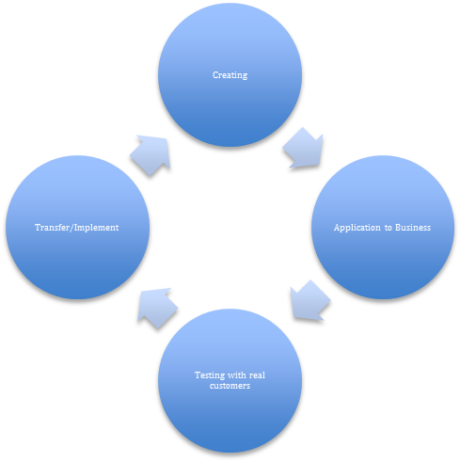
This course requires thorough preparation by the facilitators. There are plenty of online resources/lectures that the facilitator must download, read and make notes. The ratio of preparation time to implementation time is 4:1; which means a 1-hour session requires 4 hours of preparation.
Facilitate this course and adapt it to the resources you have or your participants have access to. Where they can't get online to follow lectures, the facilitator can present it as a classroom lecture. We have PPT lectures for each session.
All resources are accessed online to avoid any copyright infringement.

THE LEAN LAUNCHPAD MANIFESTO

Many entrepreneurship programs teach participants how to write business plans. Yet time and again we watched as few business plans survived first contact with customers.
It took us a while to recognize that we insisted on business plans because we assumed that startups were just smaller versions of large companies. What we’ve now realized is that they’re not.
We now know that a startup is a temporary organization designed to search for a repeatable and scalable business model. This emphasis search for a business model versus execution of a plan is the heart of the Lean Launch Pad curriculum.

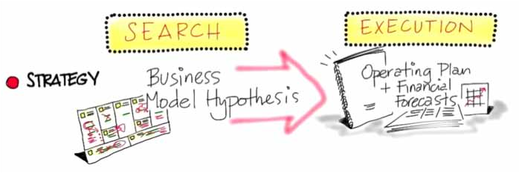
The Business Model Canvas as a Weekly Scorecard

When first starting a new venture the business model is unknown—that is, just a set of untested hypotheses—and the startup team is searching to verify its components, market, customers, features, channels, pricing, Get/Keep/Grow strategy etc. Once the business model is known, then the new venture will be executing it.

STRATEGY
The term business model first appeared around 50 years ago, but the concept didn’t catch on until the 1990s. A business model describes how a company creates, delivers and captures value. It became common to discuss business models, but without a standard framework and vernacular, confusion reigned.
In 2010, when Alexander Osterwalder published his book Business Model Generation, he provided a visual ontology and a clear vernacular that was sorely needed, and it became clear that this was the tool to organize startup hypotheses.
The primary objective of a startup is to validate its business model hypotheses until it finds one that is repeatable and scalable (it continues to iterate and pivot until it does). Then it moves into execution mode. It’s at this point that the business needs a business plan: a document that articulates the model, market, competition, operating plan, financial requirements, forecasts and other well-understood management tools.

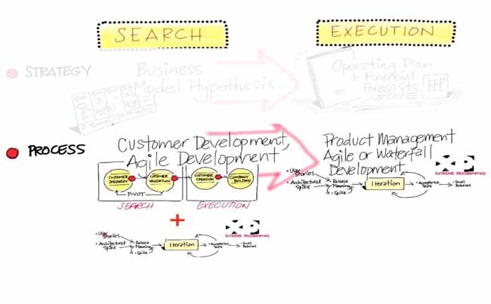

PROCESS
Yet as powerful as the Business Model Canvas (a template with the nine blocks of a business model) is, at the end of the day it’s a tool for identifying hypotheses, without a formal way of testing them. The Lean LaunchPad approach extends this process, providing a set of tools for testing hypotheses and enhancing the venture through experimentation and iteration.
The processes used to organize and implement the search for the business model are customer development and agile development. A search for a business model can occur in any new business— in a brand-new startup or in a new division of an existing company.
The customer development model breaks out all the customer-related activities of an early-stage company into four easy-to-understand steps. The first two steps of the process outline the search for the business model. Steps three and four execute the business model that’s been developed, tested and proven in steps one and two. The steps:
Customer discovery first captures the founders’ vision and turns it into a series of business model hypotheses. Then it develops a plan to test customer reactions to those hypotheses and turn them into facts.
Customer validation tests whether the resulting business model is repeatable and scalable. If not, you return to customer discovery.
Customer creation is the start of execution. It builds end-user demand and drives it into the sales channel to scale the business.
Company building transitions the organization from a startup to a company focused on executing a validated model.
In the search steps, you want a process designed to be dynamic, so you work with a rough business model description, knowing it will change. The business model changes because startups use customer development to run experiments to test the hypotheses that make up the model (first testing their understanding of the customer problem and then solutions). Most of the time these experiments fail. Search embraces failure as a natural part of the startup process. Unlike existing companies that fire executives when they fail to match a plan, we keep the founders and change the model.
Once a company has found a business model (it knows its market, customers, product/service, channel, pricing, etc.), the organization moves from search to execution.
The product execution process managing the life cycle of existing products and the launch of follow-on products is the job of the product management and engineering organizations. It results in a linear process in which you make operating plans and refine them into detail. The more granularity you add to a plan, the better people can execute it: a business requirements document BRD) leads to a market requirements document (MRD) and then gets handed off to engineering as a functional specifications document (FSD) implemented via agile or waterfall development.

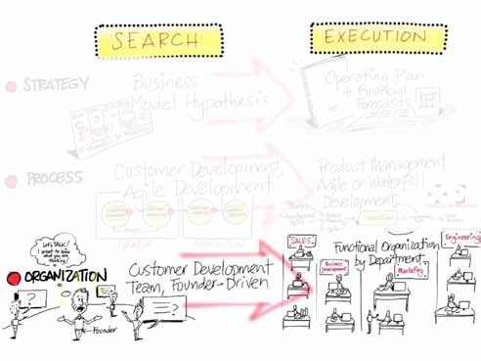

ORGANIZATION
The search for a business model requires a different organization than the one used to execute a plan. Searching requires the company to be organized around a customer development team led by the founders. It’s only the founders who can make the strategic decisions to iterate and/or pivot the business model, and to do that they need to hear customer feedback directly. In contrast, execution (which follows search) assumes that the job specifications for each of the senior roles in the company can be tightly authored. Execution requires the company to be organized by function (product management, sales, marketing, business development, etc.)
Companies in execution suffer from a “fear of failure culture,” quite understandable since they were hired to execute a known job spec. Startups with Customer Development teams have a “learning and discovery” culture for search. The fear of making a move before the last detail is nailed down is one of the biggest problems existing companies have when they need to learn how to search.
The idea of not having a functional organization until the organization has found a proven business model is one of the hardest things for new startups to grasp. There are no sales, marketing or business development departments when you are searching for a business model. If you’ve organized your startup with those departments, you are not really doing customer development. (It’s like trying to implement a startup using waterfall engineering.)

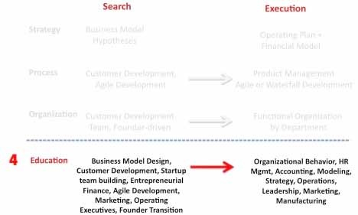

EDUCATION
Entrepreneurship curricula are only a few decades old. First taught as electives and now part of core business school curricula, the field is still struggling to escape from the bounds of the business plan–centric view that startups are smaller versions of a large company. Funders and financiers who’ve watched as no startup business plan survived first contact with customers continue to insist that startups write business plans as the price of entry to venture funding. This continues to be the case even as many of the best financiers understand that business planning, and not the plan itself, is what is important.
Entrepreneurship educators have realized that a plan-centric curriculum may get by for teaching incremental innovation, but it won’t turn out students prepared for the realities of building new ventures. Educators are now beginning to build their own E-school curriculums with a new class of management tools built around search and discovery. Business model design, product/service development, customer development, startup team building, entrepreneurial finance, marketing, founder transition, etc.: all provide the startup equivalent of the management tools MBAs learn for execution.

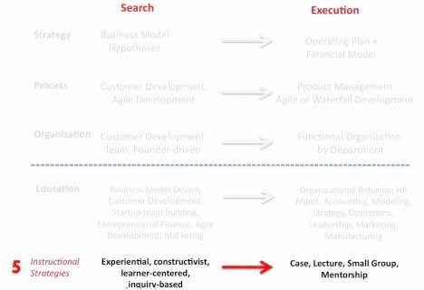

INSTRUCTIONAL STRATEGY

Entrepreneurial education is also changing the focus of the class experience from case method to hands-on experience. Invented at Harvard, the case method approach assumes that knowledge is gained when students actively participate in a discussion of a situation that may be faced by decision makers.
But the search for a repeatable business model for a new product or service does not follow a predictable pattern. An entrepreneur must start with the belief that all her assumptions are simply hypotheses that will undoubtedly be challenged by what she learns from customers. Analyzing a case in the classroom, removed from the realities of chaos and conflicting customer responses, adds little to an entrepreneur’s knowledge. Cases can’t be replicated because the world of a startup is too chaotic and complicated. The case method is the antithesis of how entrepreneurs build startups—it teaches pattern recognition tools for the wrong patterns—and therefore has limited value as a tool for teaching entrepreneurship.
The replacement for the case method is not better cases written for startups. Instead, it would be business model design: using the Business Model Canvas as a way to
- Capture and visualize the evolution of business learning in a company, and
- See what patterns match real-world iterations and pivots. It is a tool that better matches the real-world search for the business model.
In addition, teaching for the Lean LaunchPad class is typically done with a “flipped classroom.” Here, the lectures are homework (as interactive videos) (may not apply to everyone), and the homework (testing hypotheses in front of customers) is the classroom discussion, as all teams present.
There’s embarrassingly little research on entrepreneurship education and outcomes, but we do know that students learn best when they can connect with the material in a hands-on way, personally making the mistakes and learning from them directly.
As much as possible, the emphasis ought to be on experiential, learner-centric and inquiry-based classes that help to develop the mindset, reflexes, agility and resilience an entrepreneur needs to search for certainty in a chaotic world.

Lessons Learned

The search for the business model is the front end of the startup process
This is true in the smallest startup or the largest company
- The goal is to find a repeatable/scalable business model, and then execute
- Customer development and agile development are the processes for searching and building the model
- Searching for the business model comes be- fore executing it
- Execution requires operating plans and financial forecasts
- Product management is the process for executing the model
- Entrepreneurial education is developing its own management stack
- Starting with how to design and search for a business model
- Adding all the other skills startups need
- The case method is the antitheses of an entrepreneurial teaching method

THE LEAN LAUNCHPAD CLASS: GOALS

The Lean LaunchPad class is currently taught at colleges, universities, accelerators and incubators, and for the National Science Foundation. It has also been taught inside Fortune 1000 companies as a template for building new businesses. The class has different goals depending where it’s taught and who the audience is.
In a graduate engineering or business school university class, the goal of the Lean LaunchPad is to impart a methodology for scalable startups that students can use for the rest of their careers. When taught in an accelerator or incubator, the goal of the Lean LaunchPad is a series of investor-funded startups.
When taught as part of corporate entrepreneurship, the Lean LaunchPad helps existing companies to efficiently start “new” businesses.
Finally, the same Lean LaunchPad methodology, by emphasizing small-business tactics, can be used to teach how to efficiently start Main Street businesses.

Helping startups fail less often
The Lean LaunchPad doesn’t guarantee that startups will succeed. It does guarantee that if they follow this process they are less likely to fail.
We do this by rapidly helping the Lean LaunchPad student teams to personally discover that their idea is just a small part of what makes a successful company.
Here’s how we do it.

Lean LaunchPad Pedagogy: experiential Learning
The Lean LaunchPad is a hands on program that immerses student teams in testing their business model hypotheses outside the classroom. Inside the classroom, it deliberately trades lecture time for student/teaching-team interaction.
The Lean LaunchPad uses the customer development process and the Business Model Canvas to collapse the infinite possibilities of a startup into a solvable problem.
Experiential learning has been around forever. Think of the guilds, apprentices, etc. Mentors were master craftsmen. That’s the core idea of this class.
This class uses experiential learning as the paradigm for engaging the participants in discovery and hypotheses testing of their business models. From the first day we meet, the teams get out of the classroom and learn by doing.
This is very different from how a business school “how to write a business plan” class works. There, a valid business model is assumed. In this Lean LaunchPad class, the teams are not building a business (yet). What they learn from customers will validate/invalidate their hypotheses (theses), and they will modify the business model (iterate or pivot). This results in the teams’ bringing market needs forward. Then they can decide whether there’s a business to be built.
What this class does not include is execution of the business model. In this course, implementation is all about discovery outside the classroom. Once discovery has resulted in a high degree of confidence that a viable business model exists, it is time to create an execution plan. If the student teams continue with their companies, they will assemble the appropriate operating plans (financial models, revenue plans, etc.).

The flipped classroom
Instructors have the option of running a “flipped classroom.” The classroom need not be used for lectures by a live instructor. Rather, the lectures become homework. Steve Blank has recorded eight 30-minute class lectures, each with quizzes. Students can watch a lecture on each component of the Business Model Canvas, take a short quiz and have access to a class forum for questions. Their homework for that week assumes they will use that new knowledge to test that specific part of the business model. Of course, if they prefer, instructors can deliver the lectures in person.

The 10-week course, 12-week course, 5-day course
The balance of this instructor's guide provides specific and detailed guidance for offering the Lean LaunchPad course over a quarter (10 weeks) or a semester (12 weeks) as follows:
- Four-hour meeting per week for lectures, content coverage and application to business (hypothesis development)
- Four hours of customer testing and updating the BMC. It can go longer than that depending on where the customers are located.
- Four hours of classroom coaching by facilitators based field experiences.

10-week course Logistics
- Info sessions/mixers prior to the class for team formation
- The class is offered once a week
- Each class is 3 hours
- There are 8 weekly lectures, plus a 9th and a 10th week for the final team presentations (the class is easily configured for anywhere from 8 to 12 weeks.
- Three workshops are offered outside of normal class hours for customer discovery practice, details on customer acquisition and activation, and presentation skills training

Week | Lecture | Topic
6 weeks prior  4 weeks prior  2 weeks prior | Info session/Mixer  Info session/Mixer  Info session/Mixer | Course Q/A, students form teams  Course Q/A, students form teams, 1st interviews  Course Q/A, students form teams, final interviews
Week 1 | Workshop 1  Lecture 1 | Intro, business models, customer development Customer discovery practice for the real world
Week 2 | Lecture 2 | Value proposition
Week 3 | Lecture 3 | Customer segments
Week 4 | Lecture 4 | Channels
Week 4 | Workshop 2 | Customer acquisition and activation
Week 5 | Lecture 5 | Customer relationships, Get/Keep/Grow
Week 6 | Lecture 6 | Revenue model
Week 7 | Lecture 7 | Partners
Week 8 | Lecture 8 | Resources and costs
Week 8 | Workshop 3 | Presentation skills training
Week 9 | Lessons Learned | “Lessons learned” presentations teams 1-6
Week 10 | Lessons Learned | “Lessons learned” presentations teams 7-12

The optional online lectures are available via the Udacity website: http:// www.udacity.com/view#Course/nsfllp
The PowerPoint versions of the lectures are available at SlideShare: http://
www.slideshare.net/sblank/tagged/syllabus

Teaching team role and tools
For each weekly class session, students are assigned:
Pre-class readings
In-class lectures (or instructors can choose optional prerecorded online lectures with quizzes)
- An in-class 10-minute team presentation for each team presenting their lessons learned from talking with customers
- Weekly assignment to get out of the building and test one of the business model components with 10+ customers
- The last weekly sessions are “lessons learned” presentations from each team; they consist of a 2-minute video, 8-minute PowerPoint presentation or Flip charts

In class the role of the instructor is to:
- Answer questions about the on-lecture subject matter
- Critique the team presentations and offer guidance on customer discovery strategy and tactics
- Grade the student presentations and share private comments with the rest of teaching team
Outside class the role of the instructor is to:
- Review and comment weekly on each team’s customer discovery narrative
- Hold mandatory office hours weekly, cycling each team in front of a member of the teaching team at least twice

Best Practices
Some of the best practices we’ve seen work well:
- Using critiques of specific teams to make a general point for the entire class
- Trying hard not to offer students prescriptive advice or give them the answers, trying instead to teach them to see the patterns
- Adjuncts telling “war stories” with a specific lesson for the class
- Keeping in mind that everything you’re hearing from students are their hypotheses— guesses—that you want them to turn into facts
- Numbers of customer visits matter; the more visits, the more insights
- The goal is to get them to extract learning from the customer interactions
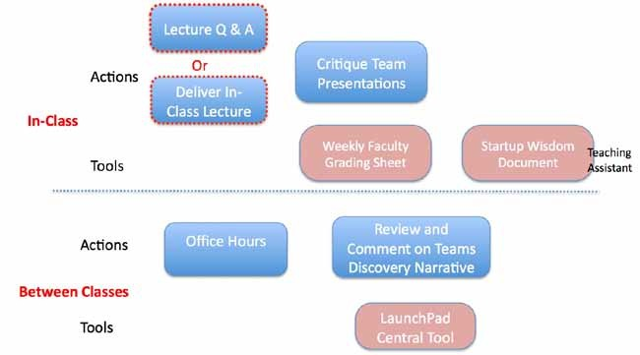
Figure 4 Teaching Team Responsibilities and Tools

Lectures
Lectures take the students through each of the Business Model Canvas components while teaching them the basics of customer development. The lecture slides are available in PowerPoint if you decide to use them in class. The lectures have also been put online at Udacity if you decide to flip the classroom and offer them as homework. If you do so, you free up more class time for Q&A about the lecture material.
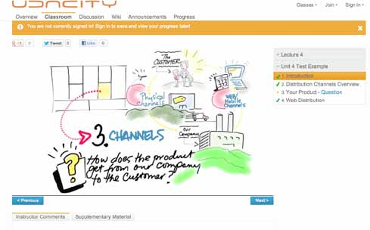

There are two required textbooks for this course:
The Startup Owner’s Manual: The Step-by-Step Guide for Building a Great Company (Steve Blank and Bob Dorf, 2012)
Business Model Generation: A Handbook for Visionaries, Game Changers and Challengers (Alexander Osterwalder, Yves Pigneur, 2010)
Lecture slides can be found here: http://www.slide- share.net/sblank/tagged/syllabus
Online lectures can be found here: http://www. udacity.com/overview/Course/nsfllp/CourseRev/1
Student presentation examples: http://www.slide-share.net/sblank/ for examples of what’s needed in team presentations

Grading
The course is team-based, and 85% of the grade will come from team progress and the final “lessons learned” presentation. The grading criteria are as follows:
• 15% Individual participation in peer grading in-class
40% Out-of-the-building progress as measured by weekly LaunchPad Central write-ups and presentationsTeam members must:
1) Update Business Model Canvas weekly 2) Write a detailed narrative on customer conversations weekly
- 20% The team in-class weekly “lessons learned” presentation
- 25% The team final “lessons learned” presentation and video

Guidelines for team Presentations
Each team is expected to speak to 10+ customers every week. The 10-minute weekly team presentations are summaries of the team’s findings during that week.
Slide 1 | Cover slide (team name, team members/roles, number of customers spoken with, what the team does)
Slide 2 | Updated Business Model Canvas
Slide 3-n | What did you learn about “topic of the day” (canvas block x)?  - Hypothesis: Here’s what we thought  - Experiments: So here’s what we did  - Results: So here’s what we found  - Iterate: So here’s what we are going to do next
Slide 4 | Diagram (if appropriate) of what you learned this week (e.g., customer workflow, payment flows, distribution channel diagram)
Feedback from the teaching team during oral presentations is where the most learning occurs. Due to the pace of the course, participants must be held accountable to the material for the specific class.

INSTRUCTOR PRE-COURSE PREPARATION

Objective: Have a basic understanding of:
- The Lean LaunchPad class
- The Business Model Canvas
- Customer development

Instructor reading Material:
- Textbooks & Advanced Viewing
- Alexander Osterwalder & Yves Pigneur, Business Model Generation (BMG) http://www.businessmod- elgeneration.com/order.php
- Steven Blank, The Startup Owners Manual (SOM) http://www.stevenblank.com/startup_index_qty. html
- Watch the Osterwalder video at:
- http://steveblank.files.wordpress.com/2012/04/osterwalder-guest-talk-012912.mov
- Review the lectures
- All PowerPoint decks here: https://www.dropbox.com/sh/gkrf8a9axfwpod3/02-jatKz4y
- Online Lectures 4-8 here
- Review the Lean LaunchPad class background
- http://steveblank.com/category/lean-launchpad/
- http://steveblank.com/2010/12/07/the-lean-launchpad-–-teaching-entrepreneurship-as-a-manage-ment-science/
- http://steveblank.com/2011/05/10/the-lean-launchpad-at-stanford-the-final-presentations/
- http://steveblank.com/2012/02/16/who-dares- wins-the-2nd-annual-international-business- model-competition/
- Look at Business Model Canvas
- http://www.businessmodelgeneration.com/ downloads/businessmodelgeneration_preview.pdf
- Read Customer Development Manifesto (chapter 2, SOM)
- Previous I-Corp Weekly and Final Presentations
- http://www.slideshare.net/sblank/tagged/i- corps
- Official lecture slides: https://www.dropbox. com/sh/x26bdshi2gorbv0/WBFzHxL1tF

DETAILED CLASS CURRICULUM

Student assignment: before the teams show up in class
Learning Objectives | Students should come to class able to answer the following questions:  (this may act as an orientation for low literate learners, who can't read in English)  - What’s the difference between search and execution?  - What is a business model vs. a business plan?  - What is the Business Model Canvas?  - What are the nine components of the Business Model Canvas?  - What is a hypothesis?  - What is customer development?  - What are the key tenets of customer development?
Why? | These are the fundamental principles of the course. Having the students prep on their own time allows us to go into full immersion on day one, first lecture.
How? | - Assign readings before the class starts. Inform students that knowing these concepts are required.  - To test their knowledge, we have each team prepare its first pass of its Business Model Canvas prior to the first class (see section 10 for description and figures)  - Teams will present their canvas as the introduction to their cohort. But more importantly, so that the teaching team can assess how adequately they prepared for the course.
Reading Assignment for day 1 of the class | Watch the Osterwalder video at:  http://steveblank.files.wordpress.com/2012/04/osterwalder-guest-talk-012912.mov  Read: Business Model Generation: pp. 14-49, Startup Owners Manual: 1-50 intro to customer development, Course strategy: http://steveblank.com/category/lean-launchpad/I-Corps team presentations: http://www.slideshare.net/sblank/tagged/i-corps.
Team Assignment for day 1 | - Prepare your team’s business model using the Business Model Canvas  - Come prepared with a customer contact/visit list that will last 3 days
Assignment Objective | - We don’t expect teams to get the canvas right. We just want them thinking hard about what it means. They will be living with the canvas for the next few months.  - Get the teams accustomed to a cover slide that provides us with a one-page summary of who they are, number of customers talked to that week, what their team does.
Presentation Guidelines | Prepare a 2-slide presentation to present your team to the cohort: Slide 1: Title slide, Slide 2: Business Model Canvas,See below for the presentation format
Hold Mentor Briefing | We suggest holding a mentor briefing an hour before the class starts. Go over the Mentor Handbook (see the appendix). Invite the mentors to the first class.

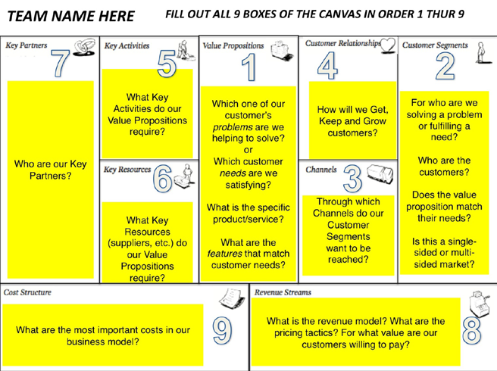

CLASS 1: INTRO & BUSINESS MODELS AND CUSTOMER DEVELOPMENT
- 1st team presentation based on pre-class reading
- In-person Lecture 0: Class Introduction
- In-person Lecture 1: Business Models and Customer Development
Teaching Objective  Student Presentations  Instructor Critiques | - Assess each team’s level of preparation and understanding.  - Introduce the Business Model Canvas development principles.  - “Shock and awe” immersion in the “present/critique” teaching method.  - Fast-paced, in-depth instructor critique and analysis of each team’s initial business models is critical during this session to emphasize to the students the level of preparation necessary.  - Have students understand that there is no such thing as spare time, and they need to be out of the building talking to customers.  - Customer development role playing: take two teams and have them role play discovery. Critique and correct the process.
Why? | These are the fundamental principles of the course.  - The format of all the classes will be:  - Teams present in front of their peers  - Teaching team critiques each student team  - Instructors lecture on a component of the Business Model Canvas  - Having the students present on day one gives them full immersion on day one, first lecture  - It also gives the teaching team the ability to provide remedial help for any team after the first day of class; in almost every class, one or two need coaching
How? | Have teams start by presenting their Business Model Canvases as their introduction to the class  - Have the teaching team immediately start offering critiques of the models and team members; an interactive dialogue is encouraged  - These first critiques should focus on value prop, customers, channels, customer relations and revenue model  - They’re usually wrong  - Don’t go deep on one team; it’s the sum of the comments across the teams that is important  - When you see a common error, announce, “This is a big idea, it’s one you will all encounter”  - Have teaching team and TA start with grading and offering first impressions of each team’s business model  - Have the students grade and comment their peers on the student Google Doc grading sheet  - Have teaching team present lectures 1-3 face-to-face to get command of the class (lectures 4-8 are recorded)

Common student errors on their 1st presentation | - Business model ignorance  - Not understanding the difference between a value prop and features  - Not understanding any detail about their customers  - No understanding of a channel  - Fantasy revenue model  - Business Model Canvas looks like a business plan  - Thinking that they’re in the class to execute their plan, not to search for one
Lecture Learning Objectives | - Start with Lecture 0, Introduction to the class and teaching team  - Next have the teams present their Business Model Canvases  - Finish with Lecture 1, Business Models/Customer Development  - Students will understand the level of hypotheses testing their business model will require  - After role-playing exercise students will have a feel for basic discovery techniques  - Lecture slides can be found here: https://www.dropbox.com/sh/x26bdshi2gorbv0/WBFzHxL1tF Students should understand the concepts of:  - 9 parts of a business model  - Hypotheses vs. facts  - Getting out of the building  - Web/mobile vs. physical  - Problem/solution  - Product/market fit  - Hypotheses/experiment design/test/insight  - Iteration vs. pivot Focus on the right half of the canvas. Students should understand the relationship between canvas components:  - Value proposition/customer segments—product market fit  - Customer relationships: get/keep/grow  - Revenue/costs—making money  - Many startups spend years attacking a small market. Having them think about the size of the opportunity early helps them keep asking, “How big can this really be? Is it worth doing?” See key lecture concept diagrams follow.
Lecture 0 Class Introduction | - Introduce the teaching team. Key concepts:  - Start by saying that the students are or will become domain experts in their fields. We will not be questioning their expertise.  - But we are the domain experts in building companies. We have a model that works, is intensive and will make all of them work extremely hard. It’s nothing personal. Key Points  - The class is all about getting out of the building  - The program is intensive and fast-paced  - The importance of actively grading their peers  - Their technology is ONE of the many critical pieces necessary to build a company and is part of the value proposition—customers do not care about their technology, rather they are trying to solve a problem Difference in customer development between web/mobile vs. physical channels

Lecture 1  Business Model Canvas & Customer Development | - Intro of the Business Model Canvas and customer development  - Definition of hypothesis  - Definition of minimum feature set  - Description of experiments  - Definition of “getting out of the building”  - Definition of market size  - How do you determine whether a business model is worth doing?  - In part 3 of the lecture, pick any one final team presentation you feel most comfortable with from http://www.slideshare.net/sblank
Reading for next week | - BMG, pp. 86-111, 135-145  - SOM, pp. 51-84, market size, value proposition and MVP pp. 188-199 getting out of the building, 457-459 market type  - What’s a Startup? First Principles: http://steveblank.com/2010/01/25/whats -a-start- up-first-principles/  - Make No Little Plans: Defining the Scalable Startup: http://steveblank.com/2010/01/04/make-no-little-plans-%E2%80%93-defining-the-scalable-startup/  - A Startup Is Not a Smaller Version of a Large Company: http://steveblank.com/2010/01/14/a-startup-is-not-a-smaller-version-of-a-large-company/  - 12 Tips for Early Customer Development Interviews: http://giffconstable.com/2010/07/12-tips-for-early-customer-development-interviews/
Assignment for next week | Lecture: Watch Lecture 2 Value Proposition—take the quiz  http://www.udacity.com/view#Course/ep245/CourseRev/1/Unit/76001/Nug- get/326002  - Presentation  - Identify your market size  - Identify your type of business (IP/licensing/startup/unknown)  - Propose experiments to test your value proposition, customer segment, channel and revenue model of your business model  - What constitutes a pass/fail signal for each test?  - See http://www.slideshare.net/sblank/tagged/i-corps for examples of what’s needed in tomorrow’s presentation  - Talk to at least 5 potential customers  - Get team blog up and post first discovery narratives
Tomorrow's Presentation Guidelines | - Slide 1: Cover slide  - Slide 2: Current Business Model Canvas with any changes marked  - Slide 3: Market size (TAM/SAM/Target)  - Slide 4: What type of business are you building? IP, licensing, startup, unknown?  - Slide 5: What are your proposed experiments for testing customer segment, value proposition, channel and revenue model of the hypotheses?  - What constitutes a pass/fail signal for each test? For example, at what point would you say that your hypothesis wasn’t even close to correct?

Teaching Assistant Activities for Classes 1–8 | Before Each Class  - Communicate with students:  - Topic to be addressed for class  - Presentation assignment  - When presentations should be uploaded to Dropbox  - Team presentation order  - Allotted time for presentation  - Location of presentation  - Preflight logistics—projectors, screens, Wi-Fi, break rooms, etc.  - Collect student slides beforehand so no individual computer setup is necessary  - Then load them on a single presentation computer  - TA to email team presentation order  - TA to keep the clock on team presentation time— announce 1 minute to go  - Have the TA prepare the shared Google Doc grading sheets  - One for the teaching team  - A separate one for the students  - TA should capture the verbal teaching-team critiques in a separate Google Doc; this should be shared with all the teams  - This should be repeated for all classes  During Each Class  - Time all presentations  - Give students 1-minute warning  After Class  - Schedule office hours
Typical Class 1 Student Business Model Canvas: A Business Plan on a Page

Lecture 1: Key Concept Diagrams

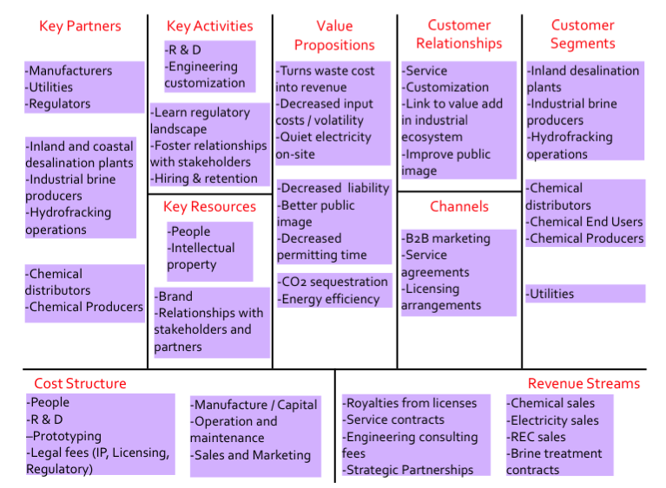

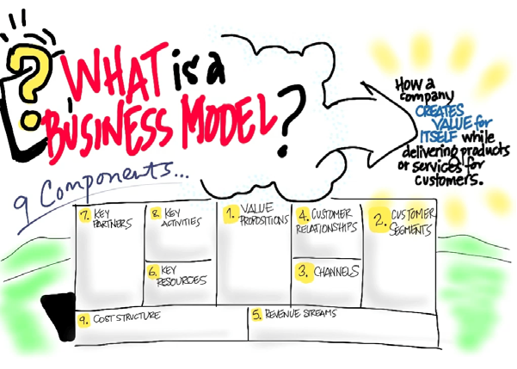

Ensure that students understand all parts of the Business Model Canvas.

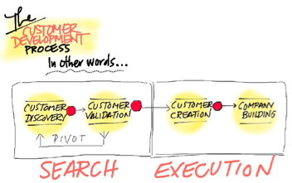
Ensure that students understand the Four Steps of Customer Development

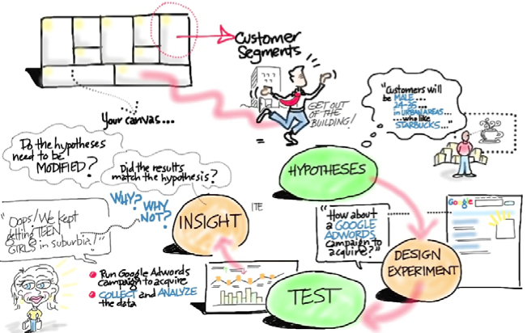

CLASS 2: VALUE PROPOSITION
- Team presentation based on Business Model Canvas and Customer Development lecture
- Lecture 2: Value Proposition (watched online before class or presented in person)
Teaching Objective  Student Presentations  Instructor Critiques | - Set expectations for:  - Customer discovery: quantity, speed and insight  - Annotation of the Business Model Canvas updates  - Their blog as “a customer discovery narrative”  - Remind them:  - Customer calls are not optional; they need to be continuous  - Hypotheses need to be turned into facts; there are no facts inside their classes  - This class is not about the execution of their original idea
How? | - Yesterday after class, the teams spoke to at least 5 customers. They were supposed to set up meetings before they arrived.  - Hang a team publicly that did not call on anyone (there’s always one)  - Stop their presentation and have them leave to make phone calls  - Tell them that if they have something to add before the rest of the presentations are over, they can present  - Make it clear that this is what the class is about  - Today’s presentation teams explain what they learned in those calls  - Have them annotate the canvas with new learning each week  - Make comments to show you’ve read their blog and that it’s critical to update  - Make sure they are articulating their hypotheses (what they expected to learn) versus what they found. Without that it’s just a bunch of random customer interviews.  - This “hypothesis>experiment>data>insight” loop is the core of the process and the class
Common student errors on their 2nd presentation | - Not enough customer calls  - Vague data from the calls  - Little to no insight from the data  - No clue about market size or overly optimistic  - Not clear whether they’re IP/licensing/startup/unknown  - Did not articulate experiments to test their hypotheses  - Did not articulate pass/fail tests for each hypothesis

Optionally, this lecture is online. All students need to watch it before class. Otherwise, the facilitator may plan to facilitate it.
Lecture 2: Value Proposition Learning Objectives | Students should understand:  - The smartest teams believe it’s all about their invention  - Your goal is to teach them it’s all about the business model  - The majority of product features are never used by customers  - The MVP and customer development eliminate waste in time/cash  - Engineers love to add features  - The goal of the MVP is to find the minimum feature set  - The difference in an MVP for a physical product vs. the low- and high-fidelity MVPs for a web/mobile product  - Explain why customer development can’t be done with Waterfall engineering but needs an Agile Development process  - Lecture slides can be found here: https://www.dropbox.com/sh/x26bdshi2gorbv0/WBFzHxL1tF See key lecture concept diagrams below.

Lecture 2: Value Proposition | - Defining your product or service  - How does it differ from an idea  - The role of pain killers, gain creators, problems/needs  - Identifying the competition and how your customers view these competitive offerings  - What’s the minimum viable product?  - What’s the market type?  - Insight into market dynamics or technological shift that makes this a fresh opportunity Instructors should emphasize:  - The difference between value proposition and feature sets  - The goal is to find the minimum viable product  - That value proposition and customers are integrated = product/market fit  - The value of annotating the Business Model Canvas  - The need to be open to changing initial Business Model Canvas hypotheses
Reading for Next Week | - BMG pp. 146-150, 161-168 and 200-211  - SOM pp. 85-97, 112-125, 203-217 problem understanding, 218-221 gain customer understanding, 260-266 product/market fit
Assignment for Next Week | Lecture: Watch Lecture 3: Customer Segments—take the quiz  http://www.udacity.com/view#Course/ep245/CourseRev/1/Unit/219001/Nug- get/288004  Presentation  - What are the pain killers, gain creators and key features?  - What is the resulting MVP?  - Propose experiments to test your value proposition  - What constitutes a pass/fail signal?  - See http://www.slideshare.net/sblank/tagged/i-corps  for examples of what’s needed in tomorrow’s presentation  - Talk to at least 5 potential customers  - Post-discovery narratives
Presentation Guidelines | - Slide 1: Cover slide  - Slide 2: Current Business Model Canvas with any changes marked  - Slide 3 What were your experiments to test value proposition?  - Slide 4: Diagram of value proposition pain/gain/features and MVP  - Slide 5-n: What did you learn about your value proposition from talking to your first customers?  - Hypothesis: Here’s what we thought  - Experiments: So here’s what we did  - Results: So here’s what we found  - Iterate: So here’s what we are going to do next

Lecture 2: Key Concept Diagrams
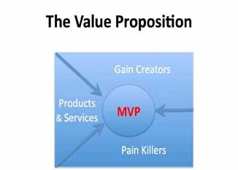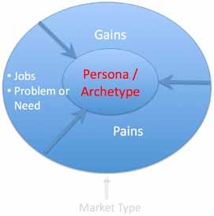
Ensure that students understand the 3 components of the Value Proposition
Casually introduce the 3 components of the Customer Segment
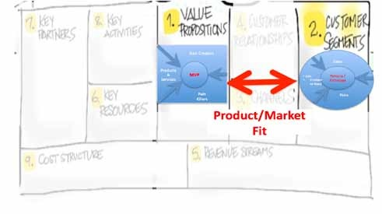
Ensure that students understand that product/market fit = Value Proposition + Customer Segment
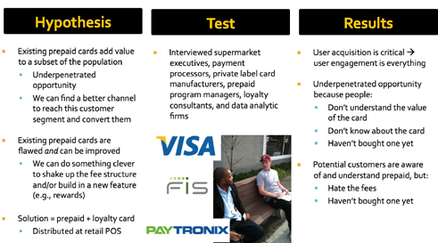
Ensure that students understand they have to articulate their hypotheses, design experiments, test and hopefully get insights.

CLASS 3: CUSTOMER SEGMENTS

- Team presentation based on Value Proposition Lecture
- Remote Lecture 3: Customer Segments
Teaching Objectives  Student Presentations  Instructor Critiques | - Continue the pace of discovery, customer calls, insights and critiques  - Make sure teams continue to:  - Annotate the Business Model Canvas with updates  - Update their blog as “a customer discovery narrative”  - Focus your main critique on their understanding of the value proposition  - Acknowledge you’ve read their blog  - Comment on other egregious parts of the canvas as necessary  - Before they leave, make sure you solve any apparent team dysfunctions
How? | - Most teams start with a value proposition equal to the feature set  - Make sure they’ve articulated pain killers, gain creators, MVP  - Use your critiques to drive them to understand what pains their value proposition is solving, what gains it is creating  - Which features will do that?  - What is the MVP to prove the value proposition?  - Start emphasizing the importance of diagrams for each component of the business model
Common student errors on their 3rd presentation | - Not enough customer calls  - Vague data from the customer calls (“They like our features ...”)  - Little to no insight from the data (“we called on 12 customers and here’s what they said ...”)  - Team thinks the purpose of the class is the execution of their idea vs. the testing of their hypotheses  - Still confused about the difference between a value proposition and features  - Confusing features with painkillers or gain creators (the value prop is not a spec sheet)  - Did not articulate experiments to test their hypotheses  - Did not articulate pass/fail tests for each hypothesis  - Missing/forgetting other key value-prop elements (competitive mapping, how customers discover you, current solution and its strengths/weaknesses)  - Settling for the “do you like my product” answer and moving on
Optionally, this lecture is online. All students need to watch it before class.

Lecture 3 Customer Segments Learning Objectives | Students should understand:  - Value proposition + customer segment = product/market fit  - Customer pains and gains  - Customer “Jobs to be done”  - Customer archetypes/personas and why they are useful  - Problem vs. Needs  - The difference between users, influencers, recommenders, decision makers, economic buyers and saboteurs  - Who will pay and why?  - Market Type—explain the difference between existing, re-segmented, new and clone markets  - Explain why it matters to know which one you are in  - The difference between single- and multi-sided markets  - Lecture slides can be found here https://www.dropbox.com/sh/x26bdshi2gorbv0/WBFzHxL1tF See key lecture concept diagrams below.
Why? | - Scientists and engineers usually have a vague sense of who will buy  - Get them started with talking to their peers, others at conferences, etc.  - Remind them that customers are the critical difference between an idea and a successful company  - Getting out of the building is about first testing their value proposition vs. customer hypotheses. At first it’s hard and awkward.  - Market Type influences how much customers can teach them
Lecture 3 Customer Segments | Instructors should emphasize:  - Customers need to match their value proposition  - Customer knowledge leads to an archetype/persona  - In a multi-sided market, each side of a market has its own value proposition, customer segment, revenue model and may have its own channel and customer relationships
Reading for next week | - BMG pp. 127-133  - SOM pp. 98 – 111, and 332-343, 406-412-Distribution Channels
Assignment for next week | Lecture: Watch Lecture 4 Distribution Channels – take the quiz  - http://www.udacity.com/view#Course/ep245/CourseRev/1/Unit/71001/Nug- get/79001  Presentation  - What are the Pains, Gains and Jobs to be done?  - Draw a diagram of the customer workflow  - What is the resulting Customer Archetype? Draw a diagram  - How do they solve this problem(s) today? Does your value proposition solve it? How?  - What was it that made customers interested? Excited?  - If your customer is part of a company, who is the decision maker, how large is their budget, what are they spending it on today, and how are they individually evaluated within that organization, and how will this buying decision be made?  - See http://www.slideshare.net/sblank/tagged/i-corps for examples of what’s needed in tomorrow’s presentation  - Talk to at least 10 potential customers  - Post discovery narratives

Presentation Guidelines | - Slide 1: Cover slide  - Slide 2: Current Business Model Canvas with any changes marked  - Slide 3 What were your experiments to test your customer segment?  - Slide 4: Diagram of archetype(s)  - Slide 5-n: What did you learn about your customers’ segments from talking to customers?  - Hypothesis: Here’s what we thought  - Experiments: So here’s what we did  - Results: So here’s what we found  - Iterate: So here’s what we are going to do next. Did anything change about value proposition?

Lecture 3: Key Concept Diagrams
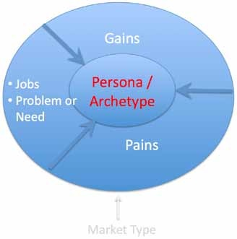
Ensure students understand the 3 components of the Customer Segment.
Ensure students understand the 4 Market Types.
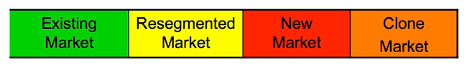
52
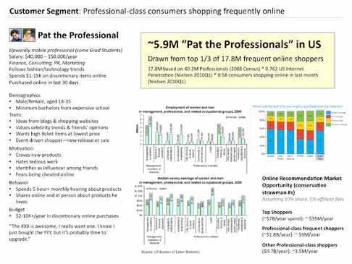
Example of a Customer Archetype/ Persona

CLASS 4: DISTRIBUTION CHANNELS

- Team Presentation based on Customer Segments Lecture
- Remote Lecture 4: Distribution Channels
Teaching Objectives Student Presentations  Instructor Critiques | - Continue the pace of discovery, customer calls, insights & critiques  - Make sure teams continue to:  - Annotate the Business Model Canvas with updates  - Include diagrams of each part of the hypothesis  - Update their blog as “a customer discovery narrative”  - Focus your main critique on their understanding of customer segments  Acknowledge you’ve read their blog  Comment on other egregious parts of the canvas as necessary
How? | Most students usually think of customers as the users of the product .  - Make sure they understand there might be multiple customer segments (users, payers, etc.)  Make sure their presentation included a customer archetype slide and a customer workflow diagram.  Ask them if they can draw a day in the life of customer. If not, tell them they don’t know enough  Use your critiques to drive them to understand what pains their customers have, what gains they are looking for and what jobs do they want done?  - Which features from the value prop will do that?  - Who specifically is (are) the archetype(s)  - Give complements to teams that drew archetypes and customer flow  - Do not be polite to those who haven’t. If you can’t draw it you don’t understand it.
Common student errors on their 4th presentation | - Not enough customer calls  - Vague data from the calls  - PI appears to be doing all the customer calls  - Mentors driving the team to an early conclusion rather than learning  - Little to no insight from the data  - Most entrepreneurs start with a vague statement such as “customer segments are end users”  - Did not articulate pass/fail tests for each hypothesis
Optionally, this lecture is online. All students need to watch it before class.

Lecture 4 Distribution Channels  Learning Objectives | Students should understand:Definition of a distributions channel  Direct, indirect and OEM  - Difference between physical and virtual channels  - Types of physical and virtual channels  - Distribution channel vs. product complexity  - Distribution channel economics. See key lecture concept diagrams below.
Why? | - Scientists and engineers think of sales as a tactic a salesperson uses  - Most entrepreneurs confuse channels with customers  - They do not understand the impact a channel can have on its revenue streams  - The more complex the channel, the smaller the margins will be There is a cost-benefit analysis made when choosing channels  - Channels are a strategy; discovering the right channel fit is an art.

Lecture 4 Distribution Channels | Instructors should emphasize:  - Channels need to match their customer segments  - Channels need to match the product (and support) complexity  - Channel economics need to match revenue goals  - Founders need to sell and close the first few orders to “prove” the channel
Reading for next week | SOM pp. 126-168 customer relationships hypotheses, pp. 296-351 Get/Keep/Grow
Assignment for next week | Lecture: Watch Lecture 5: Customer Relationships—take the quiz  http://www.udacity.com/view#Course/ep245/CourseRev/1/Unit/219002/Nug- get/321004  Presentation  - What is the distribution channel? Are there alternatives?  - Draw the channel diagram  - Annotate it with the channel economics  - What were your hypotheses about who/what your channel would be? Did you learn anything different?  - What was it that made channel partners interested? excited?  - Did anything change about value proposition or customer segment?  - See http://www.slideshare.net/sblank/tagged/i-corps  - for examples of what’s needed in tomorrow’s presentation  - Talk to at least 10 potential customers and channel partners (Salesmen, OEM’s distributors, etc.)  - Post your discovery narratives
Presentation Guidelines | - Slide 1: Cover slide  - Slide 2: Current Business Model Canvas with any changes marked  - Slide 3 What were your experiments to test your channels?  - Slide 4: Diagram of channel  - Slide 5-n: What did you learn about your channel from talking to customers?  - Hypothesis: Here’s what we thought  - Experiments: So here’s what we did  - Results: So here’s what we found  - Iterate: So here’s what we are going to do next.  Did anything change about value proposition?

Lecture 4: Key Concept Diagrams
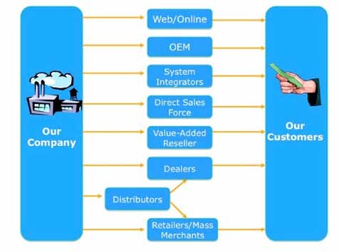
Ensure that students understand the Physical Distribution Channels alternatives.
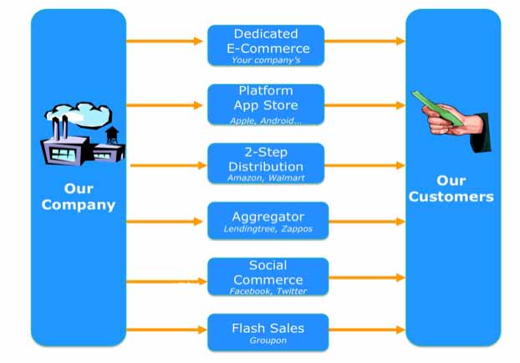
Ensure that students understand the Web/Mobile Distribution Channels.
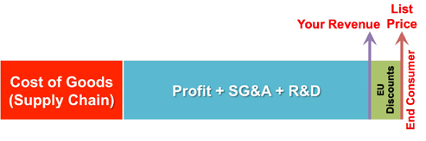
Ensure that students understand Direct Sales Channel Economics.
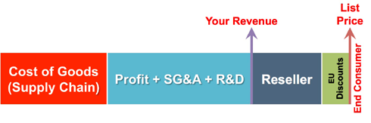
Ensure that students understand Reseller Channel Economics.
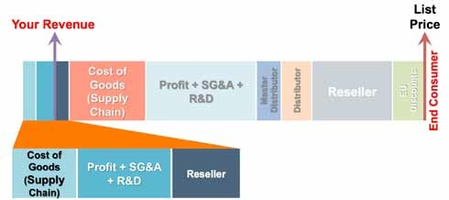
Ensure that students understand OEM Sales Channel Economics.
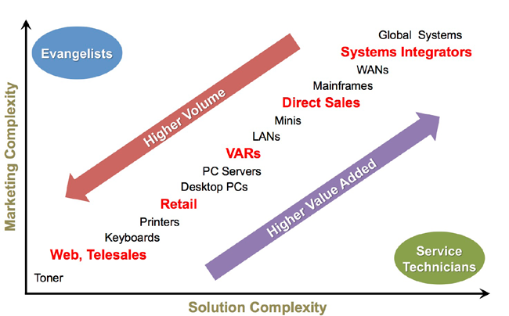
Ensure that students understand Channel versus Product Complexity.

CLASS 5: CUSTOMER RELATIONSHIPS (GET/KEEP/GROW)
- Team presentation based on Distribution Channels Lecture
- Remote Lecture 5: Customer Relationships (Get/Keep/Grow)
Teaching Objectives  Student Presentations  Instructor Critiques | - Pick up the pace of discovery, customer calls, insights & critiques  - Make sure teams continue to:  - Annotate the Business Model Canvas with updates  - Include diagrams of each part of the hypothesis  - Update their blog as “a customer discovery narrative”  - Focus your main critique on their understanding of distribution channel  - Acknowledge you’ve read their blog  - Realize some teams are in the “trough of despair”  - Comment on other egregious parts of the canvas as necessary
How? | - Most students confuse the channel with the users of the product  - Make sure their presentation included a channel diagram  - Make sure the channel diagram had the economics on it  - Use your critiques to drive them to understand:  - What type of channel they’d use  - Why they would pick that one  - How much it will cost them to use it  - Ask, “Can you draw your channel map, showing how the product moves from your startup to its end user, along with the costs and marketing/sales roles of each step in the channel?”  - Make sure they’ve diagrammed it  Do they understand the sales cycle and customer acquisition process?  - Is it repeatable and scalable? Can they prove it?  What is the length of the sales cycle?  - What are the critical points within that process?  Is your sales funnel predictable?
Common student errors on their 5th presentation | They may be stuck on their original customer segment or value prop  - By now some might need encouragement to pivot  - Some might be making lots of calls, getting lots of data, but have no clue what it means  - Students often do not ask for an order or know what it takes to get an order from the customer in their contact  - This info/feedback is key data for defining sales cycle  - Most first-time entrepreneurs confuse channels with customers  - They may not understand:  - The relationship between a channel and its revenue streams  - The more complex the channel, the smaller the margins  - The cost-benefit analysis for choosing channels  - Did not articulate experiments to test their hypotheses  - Did not articulate pass/fail tests for each hypothesis
Optionally, this lecture is online. All students need to watch it before class.

Lecture 5  Customer Relationships  Get / Keep / Grow Learning Objectives | Students should understand:  - How teams get customers into their sales channel and move them successfully through the sales cycle  - How to keep them as customers  - How to grow additional revenue from those customers over time  - Students should understand how to develop “get customer” experiments to determine tactics that move customers into and through the sales funnel in a repeatable and scalable way  - Ensure that the students have an understanding of the concept of “lifetime value of a customer” and how to calculate this figure and incorporate it into their customer acquisition strategies  - See key lecture concept diagrams below.
Why? | - Get, Keep and Grow are among the most important hypotheses for any startup to test  - Customer relationships are the result of a complex interplay among customers, sales channel, value proposition and budget for marketing  - Businesses that successfully keep their customers focus heavily on retention strategies, tactics and metrics such as purchase patterns, cohort analysis, complaints and participation in grow efforts, among others  - Multi-sided markets need separate Get, Keep and Grow strategies (e.g., users and payers)
Lecture 5  Customer Relationships  Get / Keep / Grow | Instructors should emphasize:  - Get/Keep/Grow needs to match their channel and customer segments.  - Emphasis on repeatable and scalable relationship strategies  - Sales Funnel (Customer Relationship Life Cycle)  - Awareness-Interest-Consideration-Purchase-Keep Customers-Unbundle/ Upsell-Cross-sell-Referrals  - Startups need to understand the sales cycle to Get, Keep and Grow a customer for their relevant market  - Demand creation—drives customers to chosen sales channels  - Tactics: earned and paid media & marketing, online tools  - Customer acquisition costs (CAC) and how to model/calculate  - Test your way to getting a good handle on CAC; this can put you out of business faster than anything else  - How do you validate, then scale a bit, then revalidate to be sure you have a business?  - Customer lifetime value (LTV)  - Retention strategies and tactics  - How to create end-user demand  - Difference between web and other channels  - Evangelism vs. existing need or category  - How demand creation differs in a multi-sided market
Reading for next week | SOM pp. 180-188 revenue and pricing hypotheses, 260-269 verify business model, 438- 456 metrics that matter  Watch: Mark Pincus, “Quick and Frequent Product Testing and Assessment: http:// ecorner.stanford.edu/authorMaterialInfo.html?mid=2313

Assignment for next week | Lecture  Watch Lecture 6: Revenue Streams—take the quiz  http://www.udacity.com/view#Course/ep245/CourseRev/1/Unit/73001/Nug- get/174002  Presentation  - Talk to at least 10 potential customers  - Build demand creation budget and forecast  - Create objective pass/fail metrics for each “Get” test/methodology  - What is your customer acquisition cost?  - What is your customer lifetime value?  - Did anything change about value proposition, customers/users, channel?  - Update your blog and canvas  - See http://www.slideshare.net/sblank/tagged/i-corps  - or examples of what’s needed in tomorrow’s presentation
Presentation Guidelines | - Slide 1: Cover slide  - Slide 2: Current Business Model Canvas with any changes marked  - Slide 3: What were your experiments to test getting customers?  - Slide 4: Diagram of Get/Keep/Grow  - Annotate it with costs to get customers  Slide 5-n: What did you learn about how to get, keep and grow customers?  - Hypothesis: Here’s what we thought  - Experiments: So here’s what we did  - Results: So here’s what we found  - Iterate: So here’s what we are going to do next

Lecture 5: Key Concept Diagrams
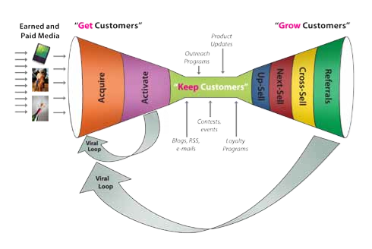
Ensure that students understand Get/Keep/Grow Customers on the Web.
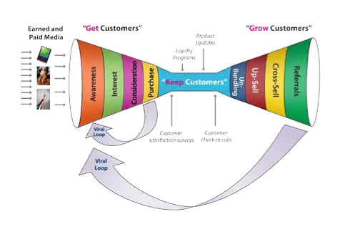
Ensure that students understand Get/Keep/Grow Customers for Physical Channels.
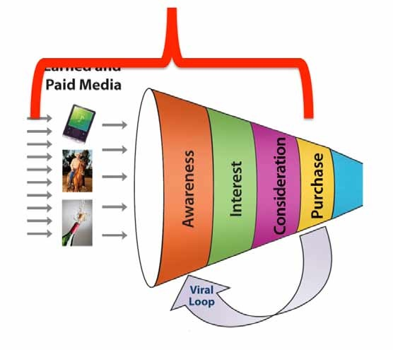
Ensure that students understand Customer Acquisition Cost (CAC).
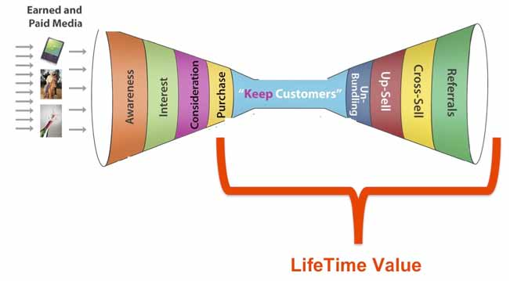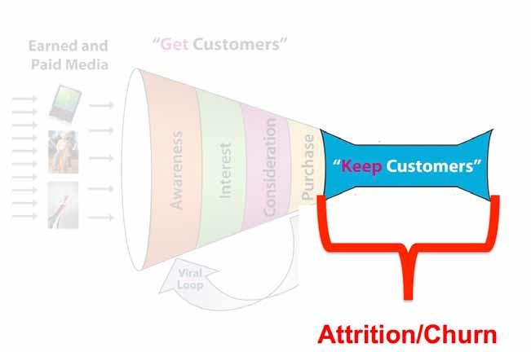

CLASS 6: REVENUE STREAMS
- Team presentation based on customer relationships lecture
- Remote Lecture 6: Revenue Streams
Teaching Objectives  Student Presentations  Instructor Critiques | Teams should be showing some real progress  - Realize some teams are in the “trough of despair”  - Do not give up on the ones who seem lost; about half of those surprise you  - Don’t let them slow down the pace of discovery and customer calls  - Make sure teams continue to:  - Annotate the Business Model Canvas with updates  - Include diagrams of each part of the hypothesis  - Update their blog as “a customer discovery narrative”  - Acknowledge you’ve read their blog  - Focus your main critique on their understanding of customer relationships  - Comment on other egregious parts of the canvas as necessary
How? | - Ask, “What earned media activities do you plan to do for your startup? What do you hope to achieve?”  - Even though they won’t have time to do real demand creation, they need to grasp the concepts of Get/Keep/Grow, CAC & LTV  - Ensure that their diagrams show funnel and real $’s for costs  - Ask, “Do you know what your customers read, what trade shows they attend, what gurus they follow, and where they turn for new product information?”
Common student errors on their 6th presentation | - To most, marketing is even more of a mystery than sales  - Let them know that the funnel is their magic decoder ring to marketing  - Students often do not understand the difference between customer acquisition and customer activation for web/mobile startups  - Online marketing is important, even if the product and sales channels are physical
Optionally, this lecture is online. All students need to watch it before class.
Lecture 6 Revenue Streams Learning Objectives | Students should understand:   Revenue model = the strategy the company uses to generate cash from each customer segment  - Direct sales, licensing, subscription  - Within the revenue model—How do I price the product?  - Pricing is a tactic  - Revenue model is the strategy  - This is not about income statement, balance sheet and cash flow. Those are operating details that are derived after a proven revenue model and pricing. See key lecture concept diagrams below.
Lecture 6 Revenue Streams | Instructors should emphasize:  - Types of revenue streams  - Revenue models  - Pricing tactics  - Physical vs. web/mobile revenue models and multi-sided market revenue models
Reading for Next Week | SOM pp. 176-179 partners, 257-270 and 429-459

Assignment for Next Week | Lecture  Watch Lecture 7: Partners—take the quiz  http://www.udacity.com/view#Course/ep245/CourseRev/1/Unit/74001/Nug- get/161001  Presentation  - Talk to at least 10 potential customers. Test pricing in front of 100 customers on the web, 10-15 customers non-web.  - What’s the revenue model strategy?  - What are the pricing tactics?  - Draw the diagram of payment flows  - What are the metrics that matter for your business model?  - Did anything change about value proposition, customers/users, channel, customer relations?  - Update your blog and canvas  - See http://www.slideshare.net/sblank/tagged/i-corps  ¤ for examples of what’s needed in tomorrow’s presentation
Presentation Guidelines | - Slide 1: Cover slide  - Slide 2: Current Business Model Canvas with any changes marked  - Slide 3: What were your hypotheses and experiments to test your revenue model and pricing tactics?  - Slide 4: Diagram of payment flows  - Slide 5-n: What did you learn about your revenue model and pricing?  - Hypothesis: Here’s what we thought  - Experiments: So here’s what we did  - Results: So here’s what we found  - Iterate: So here’s what we are going to do next

Lecture 6: Key Concept Diagrams
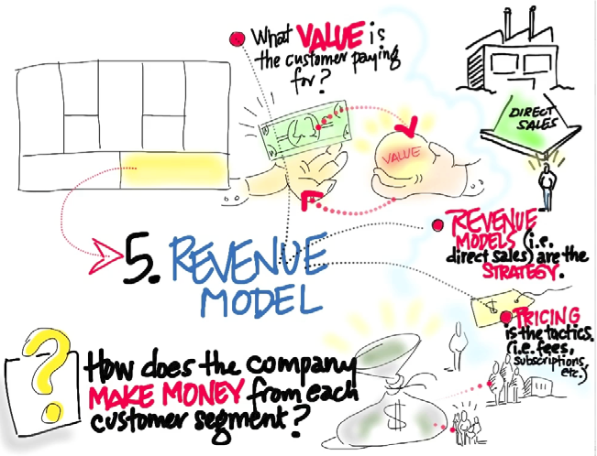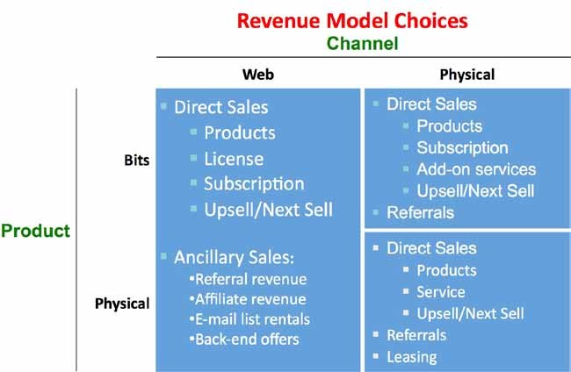

CLASS 7: PARTNERS

- Team presentation based on revenue streams lecture
- Remote Lecture 7: Partners
Teaching Objectives  Student Presentations  Instructor Critiques | Teams should be showing some real progress.  - Realize some teams are in the “trough of despair”  - Do not give up on the ones who seem lost, about half of those surprise you  - Don’t let them slow down the pace of discovery and customer calls  - Make sure teams continue to:  - Annotate the Business Model Canvas with updates  - Include diagrams of each part of the hypothesis  - Update their blog as “a customer discovery narrative”  - Acknowledge you’ve read their blog  - Focus your main critique on their understanding of revenue models and pricing  - Comment on other egregious parts of the canvas as necessary
How? | Ask:  - What is your revenue model?  - Why did you select it?  - How do customers buy today?  - What do they pay today?  - What do competitors charge?  - Does it result in a large company? Sufficient profit?
Common student errors on their 7th presentation | - Students confuse pricing tactics with revenue model strategy  - Students price on cost vs. value  - No appreciation of competitive pricing or offerings; revenue adds up to a small business  - Business too small for a company, should focus on licensing
Optionally, this is lecture is online. All students need to watch it before class.
Lecture 7 Partners Learning Objectives | Students should understand:  - What is a partner?  - Types of partners  - Risks associated with having a partner and how to manage them  - Suggestions related to selecting a partner as a startup See key lecture concept diagrams below.
Lecture 7 Partners | Instructors should emphasize:  - Who are partners  - The difference between strategic alliances, competition, joint ventures, buyers, suppliers and licensees  - While partners are critical for large companies (most companies do not do everything by themselves), strategic alliances and joint partnerships are not needed to serve early evangelists. They are needed for mainstream customers.  - For startups, partners can monopolize your time  - Partners must have aligned goals and customers  - Some examples:  - Partnership disasters: Boeing 787Strategic alliances: Starbucks partners with Pepsi, creates Frappuccino  - Joint business development: Intel partners with PC vendors  - “Coopetition”: Automotive suppliers create AIAG  - Key suppliers: Apple builds iPhone from multiple suppliers
Reading for Next Week | SOM pp.169-175 resources, 180-188 revenue and pricing

Assignment for Next Week | Lecture  Watch Lecture 8: Resources, Activities and Costs—take the quiz  http://www.udacity.com/view#Course/ep245/CourseRev/1/Unit/75001/Nug- get/77002  Presentation  Talk to at least 10 potential customers including potential partners  - What partners will you need?  - Why do you need them and what are risks?  - Why will they partner with you?  - What’s the cost of the partnership?  - Draw the diagram of partner relationships with any dollar flows  - Did anything change about value proposition or customers/users, channel, demand creation or revenue streams?  - What are the incentives and impediments for the partners?  - Update your blog and canvas  See http://www.slideshare.net/sblank/tagged/i-corps for examples of what’s needed in tomorrow’s presentation
Presentation Guidelines | - Slide 1: Cover slide  - Slide 2: Current Business Model Canvas with any changes marked  - Slide 3: What were your hypotheses experiments to test your partners?  - Slide 4: Diagram of partner relationships  - Slide 5-n: What did you learn about your partners?  - Hypothesis: Here’s what we thought  - Experiments: So here’s what we did  - Results: So here’s what we found  - Iterate: So here’s what we are going to do next

Lecture 7: Key Concept Diagrams
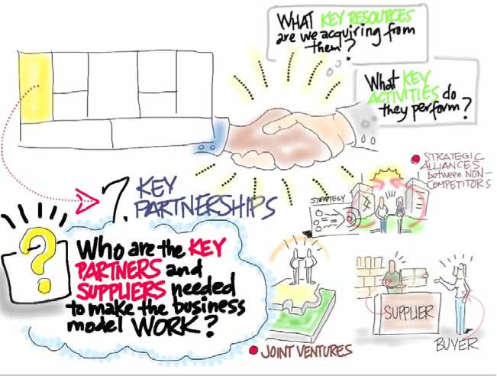

Class 8: resources, activities and costs
- Team presentation based on partners lecture
- Remote Lecture 8: Resources, Activities and Costs
Teaching Objectives  Student Presentations  Instructor Critiques | - This is the last presentation  - Teams will want to slow down or stop calling customers; don’t let them slow down the pace of discovery and customer calls  - Focus your main critique on their understanding of partners  - Comment on other egregious parts of the canvas as necessary
How? | Ask:  - How many partners have you spoken to?  - What alignment does this partner have with your customers?  - What need do you solve for this partner and how important is it to the partner?  - What economic benefit does this partner provide your business?  - How many partners are there like this?
Common student errors on their 8th presentation | - Students think their business has to do everything and don’t realize the value of a partner in their value delivery  - Students assume getting a partner is a relatively easy process  - Students confuse partnership interest with successfully closing a partnership deal  - Students confuse partnership closing with successfully executing partnership  - Students forget about channel costs and all that is part of channel costs, like SPIFs and stocking allowances
Optionally, this lecture is online. All students need to watch it before class.
Lecture 8  Resources, Activities and Costs  Learning Objectives | Students should understand:  - Cover the four categories of resources  - Cover the types of activities  - Talk about the effect of people upon the culture of the startup  - Enumerate the ways in which a startup’s intellectual property can be protected  - Add up all the costs. Is this a business worth doing?  - See key lecture concept diagrams below.
Lecture 8  Resources, Activities and Costs | Students should understand:  - Resources: financial, physical, intellectual, human capital  - Intellectual property protection. The assumed path (patents) may not be the right one to choose at this stage.  - Activities: Manufacturing? Supply chain? Problem solving?  - Costs: Fixed costs? Variable costs?
Assignment | - Keep talking to 10 customers a week  - Final 7-minute presentation and 2-minute video
Video Presentation Guidelines | See workshop 3

Lecture 8: Key Concept Diagrams
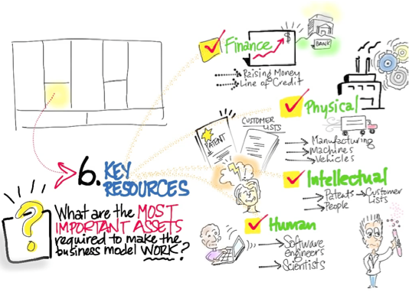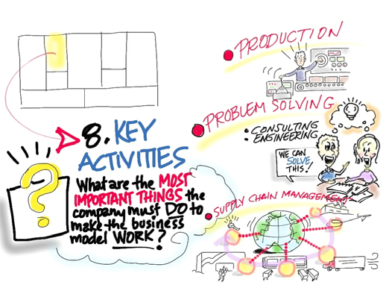
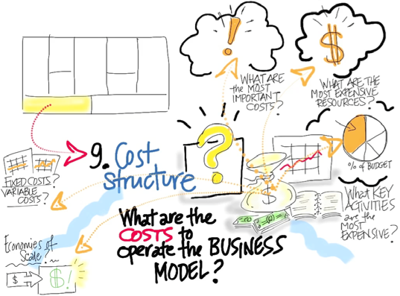

PRESENTATION SKILLS TRAINING

Teaching Objectives | Teams bring their draft final presentations, draft story video, and draft technical video. They refine and polish them throughout the day, changing slides, editing video, reshooting interviews and redoing voice-overs while receiving comments and suggestions from the instructors along the way. The emphasis is on how they present themselves and their material, with a specific focus on telling a clear and compelling story.
Format | Two weeks before the workshop  Teams are instructed to have early versions of all their presentation materials available for online review by the presentation-skills instructors the week before this workshop.  One week before the workshop  Teams are reminded to email links to their presentations and videos. Teams that followed these instructions received initial comments and suggestions via email a few days before the workshop.  The day of the workshop  - The first 30-60 minutes is spent talking about storytelling and presentation basics. (The key lecture concepts are in a later section.)  - Then instructors walk the room and work with the teams, one at a time.  - Often, a comment or suggestion comes up that all the teams would benefit from hearing. Instructors should get everyone’s attention and share it.  - After a break, each team gives their presentation to the instructors and other groups and receives notes in a formal practice session.
Assignment | Students have two deliverables for the “lessons learned” class:  - Story Video: 2-minute video focused on the journey through I-Corps as it relates to their business  - Lessons Learned Slide Deck (8 minutes for the slide presentation)
Best Practices | - Focus every bit of the team presentations (slide deck and videos) on the specifics of the company each team is starting, the specifics of the customers they met, and the specific lessons they as a company learned about their particular product or service.  - Use diagrams of what was learned: customers, channels, etc.  - Use updated Business Model Canvases to show the journey  - Teams that emailed YouTube links to their videos and slide decks several days in advance get much better feedback and have time to act on the feedback.  - Youtube is the right mechanism for sharing video for email critique; only accept YouTube links. Dropbox, and especially email attachments, bring the entire process to a standstill.

Story Video Details  (2 min.) | Think of the story video as the heart of the team presentation told with video.  Suggested Story Video Outline  - What are your names and what is your team’s name? Introduce yourselves. Pan the camera around your office so we can see where you work.  - How many customers did you talk to?  - Did you find this easy? Hard at first?  - When you started the class, what was the most important thing you thought you would have to do to successfully launch a scalable startup?  - How do you feel about that now?  - Thinking back across the class, who was the most interesting customer you met and where did you meet them?  - What happened??  - Why, specifically, was this your most interesting customer conversation?  - And how, specifically, did your business model change as a result?  - Now that the class is over, what was the most surprising thing you learned in the class?  - Teams need to see examples of story videos! Point the teams to good examples, including:  - City Climber team from City University of New York  - http://www.slideshare.net/sblank/city-climber-story-video-nsf  - RedOx team from Yale  - http://www.slideshare.net/sblank/redox-video-nsf  - Phi Optics from University of Illinois  - http://www.slideshare.net/sblank/phi-optics-story-video-nsf  - Soliculture team from UC Santa Cruz  - http://www.slideshare.net/sblank/soliculture-story-video-nsf  - NeonLabs from Carnegie Mellon University  - http://www.slideshare.net/sblank/neonlabs-story-video-nsf See all presentations and videos at: http://www.slideshare.net/sblank/tagged/i-corps

“Lessons Learned”  PowerPoint Presentation (8 min.) | The “lessons learned” slide deck is a very short list of definitions and simple declaratives that are intended to increase the quality of the presentations. Here it is, in full:  - Story  - Be specific  - Show me, don’t tell me  - Arcs  - Beginning, middle, end  - Character, setting, plot  - Editing  - Notes  - Look before...  - Practice!  - Be specific.  - Use (or enhance) the diagrams you developed in weekly presentations to illustrate these points. Instructors will find plenty of material to work with by looking at the slide decks and video links that are emailed in advance. Spend the morning sessions talking about the common pitfalls in team presentations.  - Make sure slide 1 has team name, your product, what business you ended up in and the number of customers you talked to.  - Every presentation requires a diagram of customer archetypes, customer flow, distribution channel, revenue flow.  - Every presentation requires hypotheses you tested, experiments you ran and results.  - Final slides: Click through each one of your Business Model Canvas slides. Teams need to see examples of successful presentations! Point the teams to good examples, including:  - RedOx team from Yale http://www.slideshare.net/sblank/redox-final-nsf-presentation  - NeonLabs from Carnegie Mellon University http://www.slideshare.net/sblank/lighttip-nsf-final-presentation  - Phi Optics from the University of Illinois http://www.slideshare.net/sblank/phioptics-nsf-final-presentation  - OmegaChem Iowa State University http://www.slideshare.net/sblank/omegachem-nsf-final-presentation See all presentations and videos at: http://www.slideshare.net/sblank/tagged/i-corps

Common student errors  Presentation and video | Students often make very bland story videos. They don’t naturally hone in and choose very specific details of their technology,  their customers and their learning process. This is essential, the more specific the better.  It is only through the specificity of the storytelling that an audience can extrapolate to generality, which is what one wants an investor to do.  Students often spend time thanking instructors, speaking excitedly about the Lean Launchpad program, or making cheeky references or inside jokes.  This is a big mistake that can make years of research feel like a junior high school science fair project. Students should spend absolutely zero time on any of these topics, and all meta references to how important teamwork is should be aggressively cut. This is very hard for many students to internalize.  None of that has any place in a 2-minute video about a real company that is trying to raise real money from real investors. Investors will ascertain team dynamics for themselves when they meet a given company and the people involved.  - Students think they need to tell a whitewashed success story.  - This is another mistake and will damage their attempts to get subsequent financing.  - Students must strive to tell the story of their mistakes, pitfalls discovered and pivots made.  - Most importantly, students must talk in the most specific terms possible about the customers they actually met, what they actually said, and how that changed their Business Model Canvases.  - Students don’t label their axes on graphs, label their arrows in diagrams or make a legend showing their color-coding scheme. They should.

